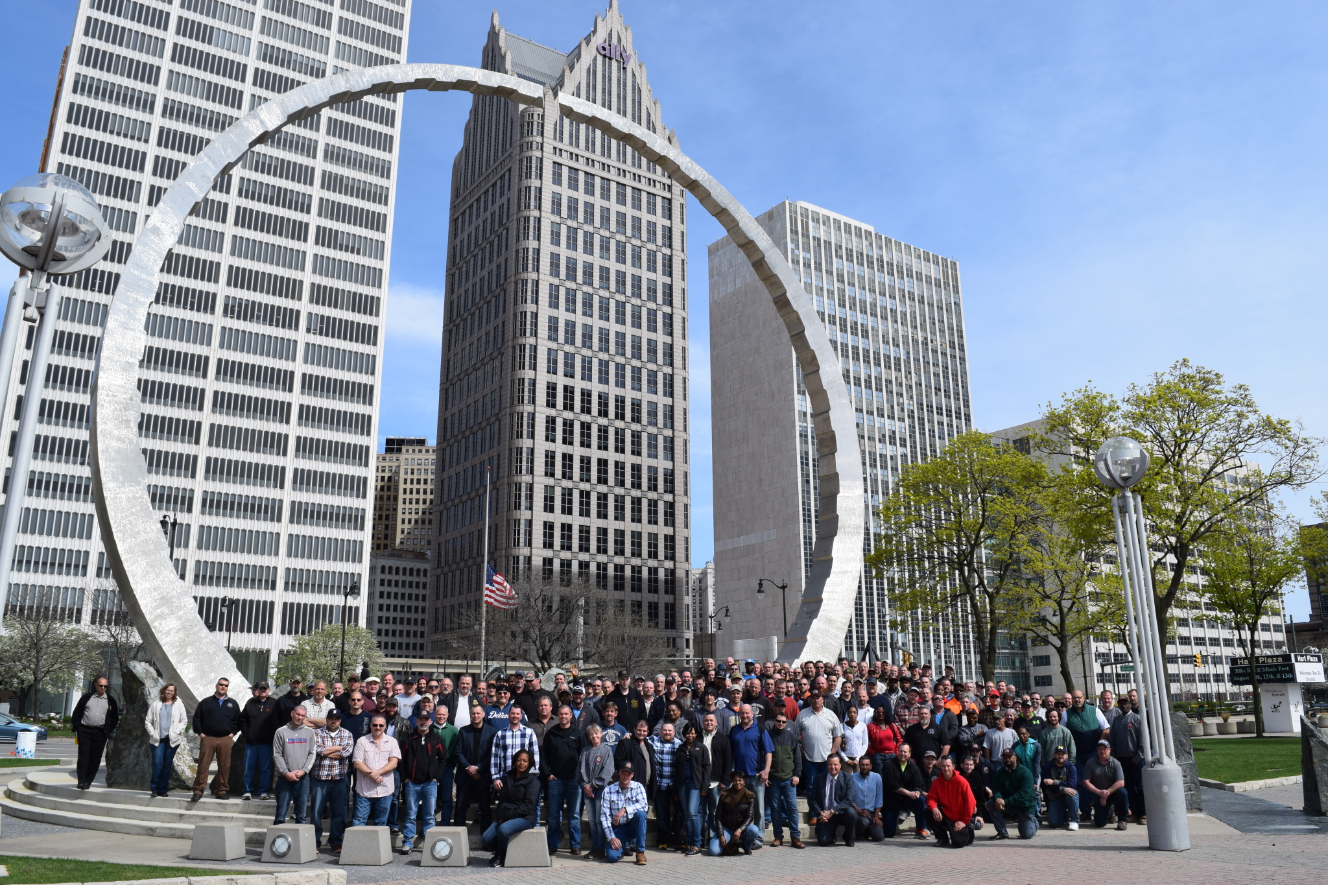
ADD YOUR NAME TO THE
LABOR LEGACY LANDMARK!

For a tax-deductible donation of $100 or more, you can add your name or the name of a family member, workmate, union brother or sister, or friend to the Wall of Honor at the Labor Legacy Landmark “Transcending” on Detroit’s waterfront. The name you choose will be etched on the panels on the east side of the plaza where this Detroit icon is situated. Funds will help pay for maintenance at the site.

To reserve a name, please print fill out this order form, scan, and e-mail it to:
Gstrassel@wayne.edu or aworker4mi@gmail.com
MICHIGAN LABOR HISTORY SOCIETY
-----------------------------------------------------------------------------------------------------------------
I would like the following name placed on the Labor Legacy wall of honor (limit 24 characters including spaces) I will make a donation of $100 when I receive my bill.

___ ___ ___ ___ ___ ___ ___ ___ ___ ___ ___ ___ ___ ___ ___ ___ ___ ___ ___ ___ ___ ___ ___ ___

Name of Donor______________________________________________________________________________________________
City_______________________________________________State__________________________________ZIP________________
E-mail_______________________________________________________Telephone_____________________________________
MICHIGAN LABOR HISTORY SOCIETY
visit us at mlhs.wayne.edu or on Facebook: Michigan Labor History Society

